LAB MANUAL

ON

User Interface Design using Flutter
Android Application Development
(with Flutter)
Tinkering Lab
ACADEMIC YEAR 2024-25
B.Tech III - I SEMESTER
(VR23)



DEPARTMENT OF COMPUTER SCIENCE

V S M COLLEGE OF ENGINEERING RAMCHANDRAPURAM
E.G DISTRICT 533255

III Year I Semester  Subject code: | USER INTERFACE DESIGN USING FLUTTER  TINKERING LAB | L | T | P | C
III Year I Semester  Subject code: | USER INTERFACE DESIGN USING FLUTTER  TINKERING LAB | 0 | 0 | 2 | 1

Course Objectives:
- Learns to Implement Flutter Widgets and Layouts
- Understands Responsive UI Design and with Navigation in Flutter
- Knowledge on Widges and customize widgets for specific UI elements, Themes
- Understand to include animation apart from fetching data

List of Experiments:
Students need to implement the following experiments

- a) Install Flutter and Dart SDK.
b) Write a simple Dart program to understand the language basics.
- a) Explore various Flutter widgets (Text, Image, Container, etc.).
b) Implement different layout structures using Row, Column, and Stack widgets.
- a) Design a responsive UI that adapts to different screen sizes.
b) Implement media queries and breakpoints for responsiveness.
- a) Set up navigation between different screens using Navigator.
b) Implement navigation with named routes.
- a) Learn about stateful and stateless widgets.
b) Implement state management using set State and Provider.
- a) Create custom widgets for specific UI elements.
b) Apply styling using themes and custom styles.
- a) Design a form with various input fields.
b) Implement form validation and error handling.
- a) Add animations to UI elements using Flutter's animation framework.
b) Experiment with different types of animations (fade, slide, etc.).
- a) Fetch data from a REST API.
b) Display the fetched data in a meaningful way in the UI.
- a) Write unit tests for UI components.
b) Use Flutter's debugging tools to identify and fix issues.

Text Books:
- Marco L. Napoli, Beginning Flutter: A Hands-on Guide to App Development.
- Rap Payne, Beginning App Development with Flutter: Create Cross-Platform Mobile Apps 1st Edition, Apres
- Richard Rose, Flutter & Dart Cookbook, Developing Full stack Applications for the Cloud, Oreilly.

Lab Session 1:

- Install flutter and Dart sdk
To install Flutter and the Dart SDK, you can follow these steps:
  - Download Flutter: Visit the Flutter website's Get Started page and download the Flutter SDK for your operating system (Windows, macOS, or Linux).

  - Extract the Flutter SDK: After downloading, extract the contents of the compressed file to a location on your computer where you want to store the Flutter SDK. For example, you can extract it to C:\flutter on Windows, /Users/<your- username>/flutter on macOS, or ~/flutter on Linux.

  - Add Flutter to your PATH: Update your system's PATH variable to include the Flutter bin directory. This step allows you to execute Flutter commands from any directory in your terminal or command prompt. The precise steps for updating the PATH vary depending on your operating system.

Windows:
From the Start search bar, type 'env' and select 'Edit the system environment variables'. Click on 'Environment Variables'.
Under 'System Variables', find the 'Path' variable, select it, and click 'Edit'.
Click 'New' and add the path to the bin directory inside the Flutter directory (e.g., C:\flutter\bin). Click 'OK' on all open dialogs to save your changes.

Verify the Flutter installation: Open a new terminal window, and run the following command to verify that Flutter is properly installed:
flutter --version
This command should display the Flutter version and other relevant information if the installation was successful.

Install Flutter dependencies: Depending on your development environment, you may need to install additional dependencies, such as Android Studio to fully set up your Flutter development environment.

Download Dart SDK (if not bundled with Flutter): Flutter comes with the Dart SDK bundled, so if you've installed Flutter, you should have the Dart SDK as well. However, if you need to install Dart separately; you can download it from the Dart "SDK archive".

- Write a simple dart program to understand the language basics
// Define a main function, which is the entry point of a Dart program.
void main() {
// Variables and data types int myNumber = 10; double myDouble = 3.14; String myString = 'Hello
World'; bool myBool = true;
// Printing variables
print('My number is: $myNumber'); print('My double is: $myDouble'); print('My string is: $myString'); print('My boolean is: $myBool');
// Basic arithmetic operations int result = myNumber + 5;
print('Result of addition: $result');
// Conditional statements if (myBool)
{
print('myBool is true');
}
else
{
print('myBool is false');
}
// Loops
for (int i = 0; i < 5; i++)
{
print('Iteration $i');
}
// Lists
List<int> numbers = [1, 2, 3, 4, 5];
print('First element of the list: ${numbers[0]}'); print('Length of the list: ${numbers.length}');
// Maps
Map<String, int> ages = { 'Kiran': 30,'Raj': 25,'Alekya': 35,}; print('Kiran\'s age: ${ages['Kiran']}' );
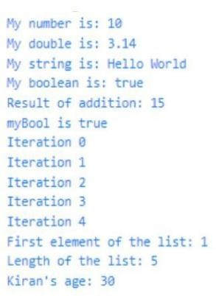
}
OUTPUT:

Lab Session 2:

Explore various flutter widgets
Flutter provides a rich set of widgets to build user interfaces for mobile, web, and desktop applications. These widgets help in creating visually appealing and interactive UIs. Here are some of the commonly used Flutter widgets categorized by their functionalities:

Layout Widgets:
Container: A versatile widget that can contain other widgets and provides options for alignment, padding, margin, and decoration.
Row and Column: Widgets that arrange their children in a horizontal or vertical line respectively.
Stack: Allows widgets to be stacked on top of each other, enabling complex layouts.

List View and Grid View: Widgets for displaying a scrollable list or grid of children, with support for various layouts and scrolling directions.

Scaffold: Implements the basic material design layout structure, providing app bars, drawers, and floatingaction buttons.

Text and Styling Widgets:
Text: Displays a string of text with options for styling such as font size, color, and alignment.
Rich Text: Allows for more complex text styling and formatting, including different styles within the same text span.

Text Style: A class for defining text styles that can be applied to Text widgets.

Input Widgets:
Text Field: A widget for accepting user input as text, with options for customization and validation.
Checkbox and Radio: Widgets for selecting from a list of options, either through checkboxes or radio buttons.

Dropdown Button: Provides a dropdown menu for selecting from a list of options.

Button Widgets:
Elevated Button and Text Button: Widgets for displaying buttons with different styles and customization options.

Icon Button: A button widget that displays an icon and responds to user taps.
Gesture Detector: A versatile widget that detects gestures such as taps, swipes, and drags, allowing for custom interactions

Image and Icon Widgets:
Image: Widget for displaying images from various sources, including assets, network URLs, and memory.
Icon: Displays a Material Design icon.

Navigation Widgets:
Navigator: Manages a stack of route objects and transitions between different screens or pages in the app.
Page Route Builder: A customizable widget for building page transitions and animations.

Animation Widgets:
Animated Container: An animated version of the Container widget, with support for transitioning properties over a specified duration.
Animated Opacity, Animated Positioned, Animated Builder: Widgets for animating opacity, position, and custom properties respectively.

Material Design Widgets:
App Bar: A material design app bar that typically contains a title, leading and trailing widgets, and actions.
Bottom Navigation Bar: Provides a navigation bar at the bottom of the screen for switching betwee different screens or tabs.

Card: Displays content organized in a card-like structure with optional elevation and padding.

Cupertino (iOS-style) Widgets:
Cupertino Navigation Bar: A navigation bar in the iOS style.
Cupertino Button: A button widget with the iOS style.
Cupertino Text Field: A text field widget with the iOS style.

These are just a few examples of the many widgets available in Flutter. Each widget comes with its set of properties and customization options, allowing developers to create highly customizable and responsive user interfaces.

b) User implement different layout structures using Row, Column, and Stack widgets
Row widgets:
import 'package:flutter/material.dart'; void main() { runApp(MyApp()); } class MyApp extends StatelessWidget { @override
Widget build(BuildContext context) {
return MaterialApp( home: MyHomePage()
);
}
}
class MyHomePage extends StatefulWidget { @override
_MyHomePageState createState() => _MyHomePageState();
}

class _MyHomePageState extends State<MyHomePage> { @override
Widget build(BuildContext context) {
return
Scaffold( appBar
: AppBar(
title: Text("Flutter Row Example"),
),
body: Row(
mainAxisAlignment: MainAxisAlignment.spaceEvenly, children:<Widget>[
Container( margin:
EdgeInsets.all(12.0), padding: EdgeInsets.all(8.0), decoration:BoxDecoration(
borderRadius:BorderRadius.circular(8), color:Colors.green
),
child: Text("React.js",style: TextStyle(color:Colors.yellowAccent,fontSize:25),),
),
Container( margin:
EdgeInsets.all(15.0), padding: EdgeInsets.all(8.0), decoration:BoxDecoration(
borderRadius:BorderRadius.circular(8), color:Colors.green
),
child: Text("Flutter",style: TextStyle(color:Colors.yellowAccent,fontSize:25),),
),
Container(

margin:
EdgeInsets.all(12.0),
padding: EdgeInsets.all(8.0), decoration:BoxDecoration(
borderRadius:BorderRadius.circular(8), color:Colors.green
),
child: Text("MySQL",style: TextStyle(color:Colors.yellowAccent,fontSize:25),),
)
]
),
);
}
}

Output:

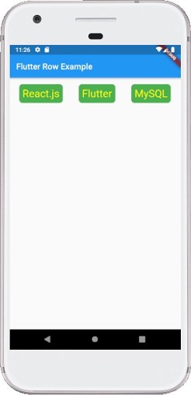

Column Widget
import 'package:flutter/material.dart';

void main() { runApp(MyApp()); } class MyApp extends StatelessWidget { @override
Widget build(BuildContext context) {
return MaterialApp( home: MyHomePage()
);
}
}

class MyHomePage extends StatefulWidget { @override
_MyHomePageState createState() => _MyHomePageState();
}
class _MyHomePageState extends State<MyHomePage> { @override
Widget build(BuildContext context) {
return
Scaffold( appBar
: AppBar(
title: Text("Flutter Column Example"),
),
body: Column(
mainAxisAlignment: MainAxisAlignment.spaceBetween, children:<Widget>[
Container(
margin: EdgeInsets.all(20.0), padding: EdgeInsets.all(12.0), decoration:BoxDecoration(
borderRadius:BorderRadius.circular(8), color:Colors.red
),
child: Text("React.js",style: TextStyle(color:Colors.yellowAccent,fontSize:20),),
),
Container(
margin: EdgeInsets.all(20.0), padding: EdgeInsets.all(12.0), decoration:BoxDecoration(
borderRadius:BorderRadius.circular(8), color:Colors.red
),
child: Text("Flutter",style: TextStyle(color:Colors.yellowAccent,fontSize:20),),
),
Container(
margin: EdgeInsets.all(20.0), padding: EdgeInsets.all(12.0),

decoration:BoxDecoration( borderRadius:BorderRadius. circular(8), color:Colors.red
),
child: Text("MySQL",style: TextStyle(color:Colors.yellowAccent,fontSize:20),),
)
]
),
);
}
}

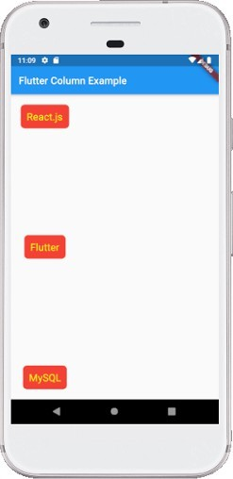
Output:

Stack Widget
import 'package:flutter/material.dart';

void main() => runApp(MyApp());

/// This Widget is the main application widget. class MyApp extends StatelessWidget { @override
Widget build(BuildContext context) {
return
MaterialApp( home:
MyStackWidget(),
);
}
}

class MyStackWidget extends
StatelessWidget { @override
Widget build(BuildContext context) {
return MaterialApp( ho me:
Scaffold( appBar
: AppBar(
title: Text("Flutter Stack Widget Example"),
),
body:
Center( ch ild: Stack( fit:
StackFit.passthrough, overflow:
Overflow.visible, children: <Widget>[
// Max Size Widget Container(
height: 300,
width: 400, color:
Colors.green, child: Center( child: Text(
'Top Widget: Green',
style: TextStyle(color: Colors.white, fontSize: 20),
),
),
),
Positioned ( top: 30,
right: 20, child:
Container( h eight: 100,
width: 150, color:
Colors.blue, child:
Center( child:
Text(
'Middle Widget',
style: TextStyle(color: Colors.white, fontSize: 20),
),
),
),
),
Positioned ( top: 30,
left: 20, child:
Container( h eight: 100,
width: 150, color:
Colors.orange, child: Center( child: Text(
'Bottom Widget',
style: TextStyle(color: Colors.white, fontSize: 20),
),
),
)
),
],
),
)
),
);
}
}

Output:
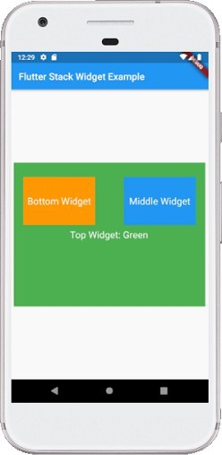

Lab Session 3:

- Design a responsive UI that adapts to different screen sizes

import 'package:flutter/material.dart'; void main()
{
runApp(MyApp());
}
class MyApp extends StatelessWidget { @override
Widget build(BuildContext context) {
return MaterialApp(
title: 'Responsive UI Demo', theme:
ThemeData( primarySwatch: Colors.blue,
),
home: ResponsiveHomePage(),
);
}
}

class ResponsiveHomePage extends StatelessWidget { @override
Widget build(BuildContext context) { return Scaffold(
appBar: AppBar(
title: Text('Responsive UI Demo'),
),
body: LayoutBuilder(
builder: (BuildContext context, BoxConstraints constraints) { if (constraints.maxWidth < 600) {
return _buildNarrowLayout();
} else {
return _buildWideLayout();
}
},
),
);
}

Widget _buildNarrowLayout() { return Center( child: Column(
mainAxisAlignment: MainAxisAlignment.center, children:
<Widget>[ FlutterLogo (size: 100),
SizedBox(height: 20), Text(

'Narrow Layout',
style: TextStyle(fontSize: 24),
),
SizedBox(height: 20), ElevatedButton( onPressed: () {}, child: Text('Button'),
),
],
),
);
}

Widget _buildWideLayout() { return Center( child: Row(
mainAxisAlignment: MainAxisAlignment.center, children:
<Widget>[ FlutterLogo (size: 100),
SizedBox(width: 20), Column(
mainAxisAlignment: MainAxisAlignment.center, children:
<Widget>[ Text(
'Wide Layout',
style: TextStyle(fontSize: 24),
),
SizedBox(height: 20), ElevatedButton( onPressed: () {}, child: Text('Button'),
),
],
),
],
),
);
}
}

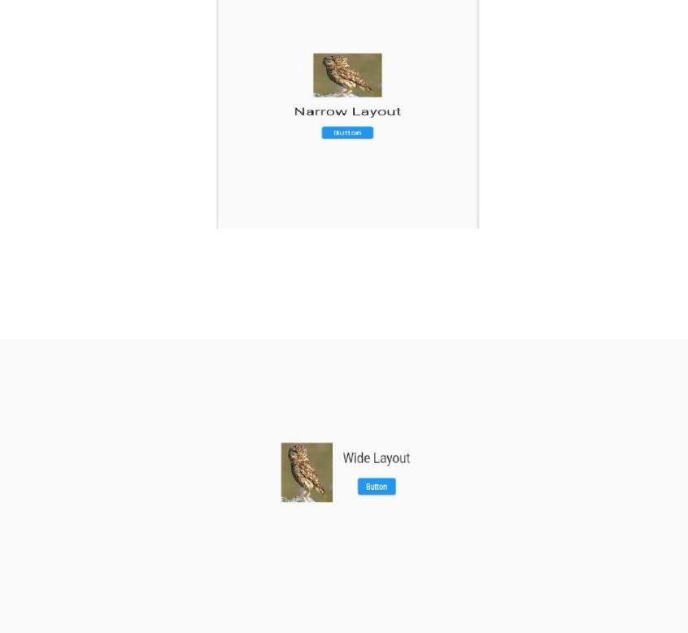
Output::

- Implement media queries and breakpoints for responsiveness

import 'package:flutter/material.dart';

void main() {
runApp(MyApp());
}

class MyApp extends StatelessWidget {
@override
Widget build(BuildContext context) {
return MaterialApp(
title: 'Responsive UI with Media Queries',
theme: ThemeData(
primarySwatch: Colors.blue,
),
home: ResponsiveHomePage(),
);
}
}

class ResponsiveHomePage extends StatelessWidget {
@override
Widget build(BuildContext context) {
return Scaffold(
appBar: AppBar(
title: Text('Responsive UI with Media Queries'),
),
body: LayoutBuilder(
builder: (BuildContext context, BoxConstraints constraints) {
if (constraints.maxWidth < 600) {
return _buildMobileLayout();
} else if (constraints.maxWidth < 1200) {
return _buildTabletLayout();
} else {
return _buildDesktopLayout();
}
},
),
);
}

Widget _buildMobileLayout() {
return Center(
child: Column(
mainAxisAlignment: MainAxisAlignment.center,
children: <Widget>[
FlutterLogo(size: 100),
SizedBox(height: 20),
Text(
'Mobile Layout',
style: TextStyle(fontSize: 24),
),
SizedBox(height: 20),
ElevatedButton(
onPressed: () {},
child: Text('Button'),
),
],
),
);
}

Widget _buildTabletLayout() {
return Center(
child: Row(
mainAxisAlignment: MainAxisAlignment.center,
children: <Widget>[
FlutterLogo(size: 100),
SizedBox(width: 20),
Column(
mainAxisAlignment: MainAxisAlignment.center,
children: <Widget>[
Text(
'Tablet Layout',
style: TextStyle(fontSize: 24),
),
SizedBox(height: 20),
ElevatedButton(
onPressed: () {},
child: Text('Button'),
),
],
),
],
),
);
}

Widget _buildDesktopLayout() {
return Center(
child: Row(
mainAxisAlignment: MainAxisAlignment.center,
children: <Widget>[
FlutterLogo(size: 100),
SizedBox(width: 20),
Column(
mainAxisAlignment: MainAxisAlignment.center,
children: <Widget>[
Text(
'Desktop Layout',
style: TextStyle(fontSize: 24),
),
SizedBox(height: 20),
ElevatedButton(
onPressed: () {},
child: Text('Button'),
),
],
),
],
),
);
}
}

OUTPUT:

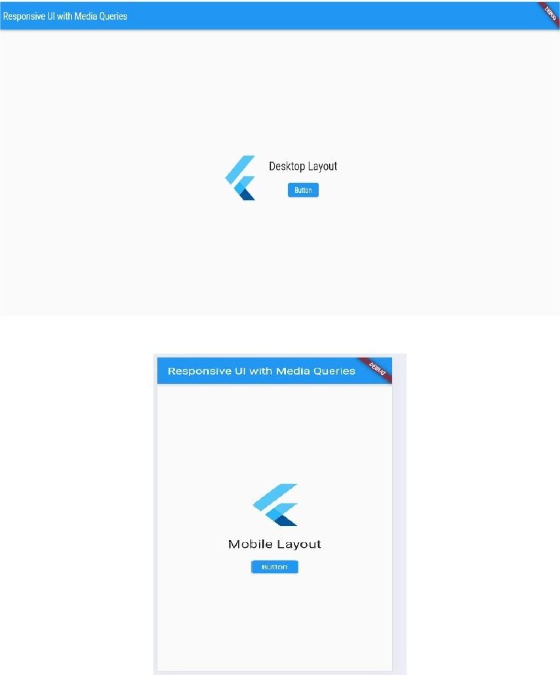

Lab Session 4:
- Setup navigation between different screens using navigator
import 'package:flutter/material.dart';

void main() {
runApp(MyApp());
}

class MyApp extends StatelessWidget {
@override
Widget build(BuildContext context) {
return MaterialApp(
title: 'Navigation Example',
theme: ThemeData(
primarySwatch: Colors.blue,
),
home: FirstScreen(),
);
}
}

class FirstScreen extends StatelessWidget {
@override
Widget build(BuildContext context) {
return Scaffold(
appBar: AppBar(
title: Text('First Screen'),
),
body: Center(
child: ElevatedButton(
onPressed: () {
// Navigate to the second screen
Navigator.push(
context,
MaterialPageRoute(builder: (context) => SecondScreen()),
);
},
child: Text('Go to Second Screen'),
),
),
);
}
}

class SecondScreen extends StatelessWidget {
@override
Widget build(BuildContext context) {
return Scaffold(
appBar: AppBar(
title: Text('Second Screen'),
),
body: Center(
child: ElevatedButton(
onPressed: () {
// Navigate back to the first screen
Navigator.pop(context);
},
child: Text('Go back to First Screen'),
),
),
);
}
}

Output::
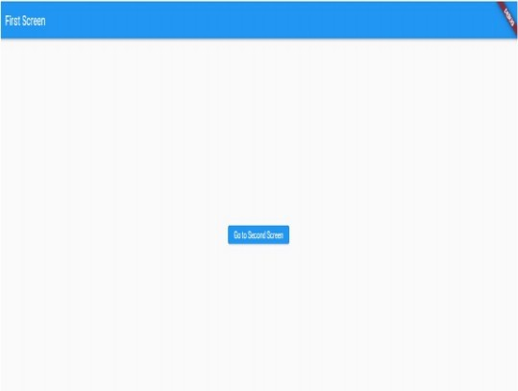

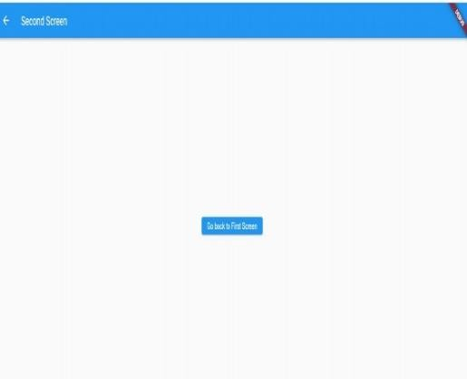

- Implement navigation with named routes
import 'package:flutter/material.dart';

void main() => runApp(ResponsiveImageApp());

class ResponsiveImageApp extends StatelessWidget {
@override
Widget build(BuildContext context) {
return MaterialApp(
title: 'Mobile Layout Only',
debugShowCheckedModeBanner: false,
home: MobileLayout(),
);
}
}

// 📱 Mobile Layout
class MobileLayout extends StatelessWidget {
@override
Widget build(BuildContext context) {
return Scaffold(
appBar: AppBar(title: Text('Mobile Layout')),
body: Column(
children: [
HeaderWidget(),
Expanded(
child: Center(
child: ResponsiveImage(
imageWidth: MediaQuery.of(context).size.width * 0.8,
),
),
),
],
),
);
}
}

// 🧩 Reusable Header Widget
class HeaderWidget extends StatelessWidget {
@override
Widget build(BuildContext context) {
return Container(
color: Colors.blue,
height: 60,
width: double.infinity,
alignment: Alignment.center,
child: Text(
'Mobile Header',
style: TextStyle(color: Colors.white, fontSize: 20),
),
);
}
}

// 🖼️ Responsive Image Widget
class ResponsiveImage extends StatelessWidget {
final double imageWidth;

const ResponsiveImage({required this.imageWidth});

@override
Widget build(BuildContext context) {
return Image.network(
'https://flutter.dev/assets/homepage/carousel/slide_1-layer_0-frame-8e0496a0b34ce70828d8c06e1b1d78c92f55cdb8b1934b8a632bfa0d6c9d088d.png',
width: imageWidth,
);
}
}

Output::

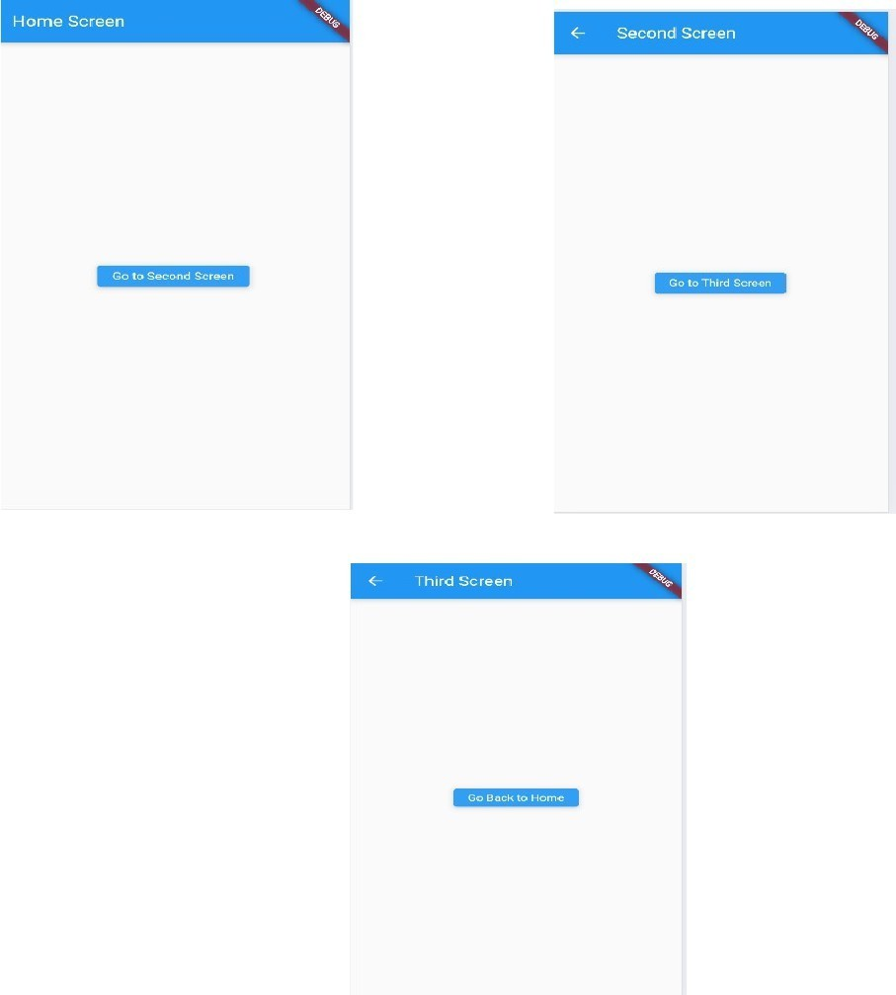

Lab Session 5:

  - Learn about stateful and stateless widgets
In Flutter, widgets can be categorized into two main types based on their behavior regarding state management: stateful widgets and stateless widgets.
Stateless Widgets:
Definition: Stateless widgets are widgets that do not have any mutable state. Once created, their properties (configuration) cannot change.
Characteristics:
They are immutable and lightweight.
They only depend on their configuration and the build context provided during construction. Their appearance (UI) is purely a function of their configuration.
They are ideal for UI elements that do not change over time, such as static text labels, icons, or simple buttons.
import 'package:flutter/material.dart'; void main()
{
runApp(MyApp());
}

class MyApp extends StatelessWidget { @override
Widget build(BuildContext context)
{ return MaterialApp( home: Scaffold( appBar: AppBar(
title: Text('Cards Example'),
),
body: CardList(),
),
);
}
}

class CardList extends StatelessWidget { @override
Widget build(BuildContext context)
{ return ListView.builder( itemCount: 10,
itemBuilder: (context, index)
{ return CardItem( title: 'Card $index',
subtitle: 'Subtitle $index',

);
},
);
}
}

class CardItem extends StatelessWidget { final String title;
final String subtitle;

const CardItem({ Key key, @required this.title,
@required this.subtitle,
}) : super(key: key);

@override
Widget build(BuildContext context)
{ return Card(
margin: EdgeInsets.symmetric(horizontal: 16, vertical: 8), child:
ListTile( title:
Text(title),
subtitle: Text(subtitle), leading: CircleAvatar(
child: Text('${title.substring(0, 1)}'),
),
onTap: () {
// Handle card tap
},
),
);
}

Output::
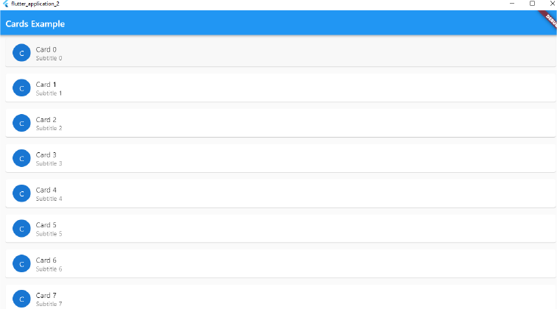

  - Implement state management using set state and provider
Stateful Widgets:

Definition: Stateful widgets are widgets that maintain state, allowing them to change and update over time inresponse to user actions, network events, or other factors.

Characteristics:
They have an associated mutable state that can change during the widget's lifetime. The state is stored in a separate class that extends State and is associated with the stateful widget. Changes to the state trigger a rebuild of the widget's UI, allowing dynamic updates.

They are ideal for UI elements that need to change or react to user interactions, such as input forms, animations, or scrollable lists.

import 'package:flutter/material.dart';

void main() {
runApp(SetStateApp());
}

class SetStateApp extends StatefulWidget {
@override
_SetStateAppState createState() => _SetStateAppState();
}

class _SetStateAppState extends State<SetStateApp> {
int _counter = 0;

void _increment() {
setState(() {
_counter++;
});
}

void _decrement() {
setState(() {
_counter--;
});
}

@override
Widget build(BuildContext context) {
return MaterialApp(
title: 'setState Demo',
home: Scaffold(
appBar: AppBar(title: Text('setState Counter')),
body: Center(
child: Text(
'Counter: $_counter',
style: TextStyle(fontSize: 34),
),
),
floatingActionButton: Row(
mainAxisAlignment: MainAxisAlignment.end,
children: [
FloatingActionButton(
heroTag: 'dec',
onPressed: _decrement,
child: Icon(Icons.remove),
),
SizedBox(width: 10),
FloatingActionButton(
heroTag: 'inc',
onPressed: _increment,
child: Icon(Icons.add),
),
],
),
),
);
}
}

Output::

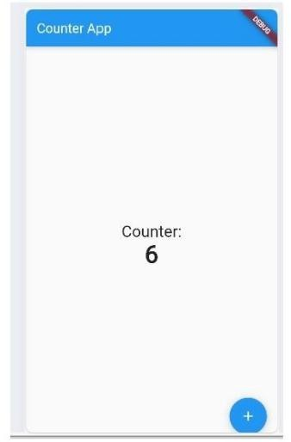

State Management using setState():
import 'package:flutter/material.dart'; void main()
{ runApp(MyApp());
}

class MyApp extends StatelessWidget { @override
Widget build(BuildContext context) { return MaterialApp(
home: CounterPage(),
);
}
}

class CounterPage extends StatefulWidget { @override
_CounterPageState createState() => _CounterPageState();
}

class _CounterPageState extends State<CounterPage> { int
_counter = 0;
void _incrementCounter() { setState(() {
_counter++;
});
}
@override
Widget build(BuildContext context) { return Scaffold(
appBar: AppBar(
title: Text('Counter Example (setState)'),

),
body: Center( child: Column(
mainAxisAlignment: MainAxisAlignment.center, children:
<Widget>[ T ext(
'Counter Value:',
),
Text( '$_counter',
style: Theme.of(context).textTheme.headline4,
),
],
),
),
floatingActionButton: FloatingActionButton( onPressed: _incrementCounter,
tooltip: 'Increment', child: Icon(Icons.add),
),
);
}
}

Output::

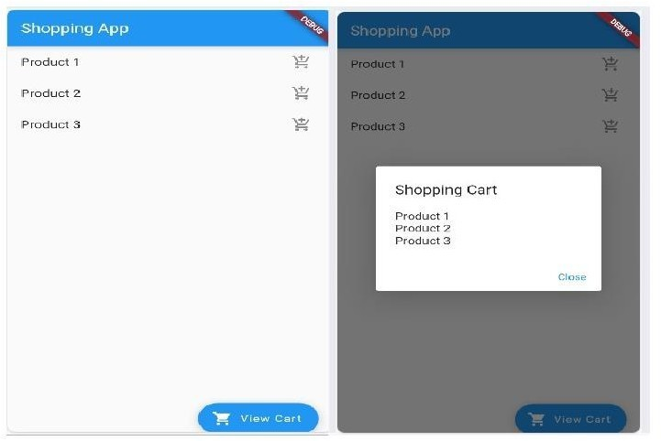

State Management using provider package:
// main.dart
import 'package:flutter/material.dart'; import 'package:provider/provider.dart';
import 'provider/movie_provider.dart';
import 'screens/home_screen.dart'; void main() {
runApp(ChangeNotifierProvider<MovieProvider>(
child: const MyApp(),
create: (_) => MovieProvider(), // Create a new ChangeNotifier object
));
}

class MyApp extends StatelessWidget {
const MyApp({Key? key}) : super(key: key);
@override
Widget build(BuildContext context) {
return MaterialApp(
// Remove the debug banner debugShowCheckedModeBanner: false, title: 'State Management using provider', theme: ThemeData(
primarySwatch: Colors.indigo,
),

home: const HomeScreen(),
);
}
}

create a model folder for models and create file movie.dart class Movie {
final String title;
final String? runtime; // how long this movie is (in minute)

Movie({required this.title, this.runtime});
}
Create a provider folder and create movie_provider.dart inside the provider folder
// provider/movie_provider.dart import 'package:flutter/material.dart'; import 'dart:math';

import '../models/movie.dart';

// A list of movies
final List<Movie> initialData = List.generate( 50, (index) => Movie(
title: "Moview $index",
runtime: "${Random().nextInt(100) + 60} minutes"));
class MovieProvider with ChangeNotifier {
// All movies (that will be displayed on the Home screen) final List<Movie> _movies = initialData;

// Retrieve all movies
List<Movie> get movies => _movies;

// Favorite movies (that will be shown on the MyList screen) final List<Movie> _myList = [];

// Retrieve favorite movies List<Movie> get myList => _myList;

// Adding a movie to the favorites list void addToList(Movie movie) {
_myList.add(movie); notifyListeners();
}

// Removing a movie from the favorites list void removeFromList(Movie movie) {
_myList.remove(movie); notifyListeners();
}
}

Create a screens folder for screens
// screens/home_screen.dart
import 'package:flutter/material.dart'; import 'package:provider/provider.dart'; import '../provider/movie_provider.dart'; import 'my_list_screen.dart';
class HomeScreen extends StatefulWidget {
const HomeScreen({Key? key}) : super(key: key); @override
State<HomeScreen> createState() => _HomeScreenState();
}
class _HomeScreenState extends State<HomeScreen> {

@override
Widget build(BuildContext context) {
var movies = context.watch<MovieProvider>().movies; var myList = context.watch<MovieProvider>().myList;
return Scaffold( appBar: AppBar(
title: const Text('State Management using provider'),
),
body: Padding(
padding: const EdgeInsets.all(15), child: Column(
crossAxisAlignment: CrossAxisAlignment.stretch,
children: [ ElevatedButton.icon( onPressed: () {
Navigator.of(context).push( MaterialPageRoute(
builder: (context) => const MyListScreen(),
),
);
},
icon: const Icon(Icons.favorite), label: Text( "Go to my list (${myList.length})", style: const TextStyle(fontSize: 24),
),
style:
ElevatedButton.styleFrom( primar y:Colors.red,
padding: const EdgeInsets.symmetric(vertical: 20)),
),
const SizedBox( height: 15,
),
Expanded(
child: ListView.builder( itemCount: movies.length, itemBuilder: (_, index)
{ final currentMovie = movies[index]; return Card(
key: ValueKey(currentMovie.title), color: Colors.amberAccent.shade100, elevation: 4, child: ListTile(
title: Text(currentMovie.title), subtitle: Text(currentMovie.runtime ?? 'No information'),
trailing: IconButton(
icon: Icon( Icons.favorite,
color: myList.contains(currentMovie)
? Colors.red
: Colors.white,
size: 30,
),
onPressed: () {
if (!myList.contains(currentMovie)) { context

.read<MovieProvider>()
.addToList(currentMovie);
} else { context
.read<MovieProvider>()
.removeFromList(currentMovie);
}
},
),
),
);
}),
),
],
),
),
);
}
}

create my_list_screen.dart inside the screens folder
// screens/my_list_screen.dart
import 'package:flutter/material.dart'; import 'package:provider/provider.dart';
import '../provider/movie_provider.dart'; class MyListScreen extends StatefulWidget {
const MyListScreen({Key? key}) : super(key: key);
@override
State<MyListScreen> createState() => _MyListScreenState();
}
class _MyListScreenState extends State<MyListScreen> { @override
Widget build(BuildContext context) {
final myList = context.watch<MovieProvider>().myList; return Scaffold(
appBar: AppBar(
title: Text("My List (${myList.length})"),
),
body: ListView.builder( itemCount: myList.length, itemBuilder: (_, index)
{ final currentMovie = myList[index];
return Card(
key: ValueKey(currentMovie.title), elevation: 4, child: ListTile(

title: Text(currentMovie.title),
subtitle: Text(currentMovie.runtime ?? ''), trailing: TextButton(
child: const Text( 'Remove',
style: TextStyle(color: Colors.red),
),
onPressed: () { context.read<MovieProvider>().removeFromList(currentMovie);
},
),
),
);
}); }),
}

Output::
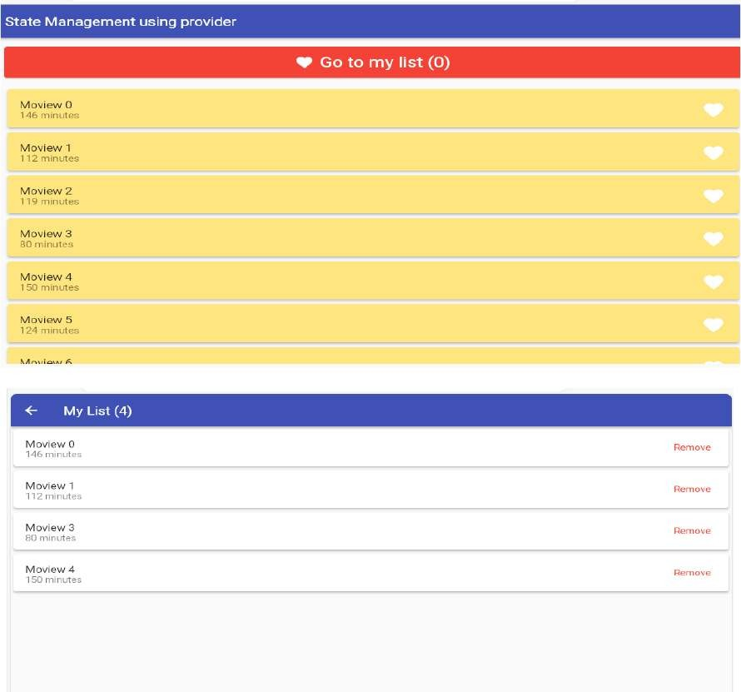

.
Lab Session 6:
  - Create custom widgets for specific UI elements
import 'package:flutter/material.dart'; void main() {
runApp(MyApp());
}

class MyApp extends StatelessWidget { @override
Widget build(BuildContext context) { return MaterialApp(
home: Scaffold( appBar: AppBar(
title: Text('Custom Widget Example'),
),
body: Column(
mainAxisAlignment: MainAxisAlignment.center, children:
<Widget>[ P adding(
padding: const EdgeInsets.all(8.0), child: CustomTextField(
hintText: 'Enter your name', onChanged: (value) { print('Name changed: $value');
},
),
),
SizedBox(height: 20), Padding(
padding: const EdgeInsets.all(8.0), child: CustomTextField(
hintText: 'Enter Email', onChanged: (value)
{ print('Name changed: $value');
},
),
),
SizedBox(height: 20), Padding(
padding: const EdgeInsets.all(8.0), child: CustomTextField(
hintText: 'Enter Roll Number', onChanged: (value) { print('Name changed: $value');
},
),
),
SizedBox(height: 20), CustomButton( text: 'Press Me',
onPressed: () {

print('Button pressed!');
},
),
],
),
),
);
}
}

class CustomButton extends StatelessWidget { final String? text;
final VoidCallback? onPressed;

const CustomButton({ Key? key, @required this.text,
@required this.onPressed,
}) : super(key: key);

@override
Widget build(BuildContext context) { return ElevatedButton(
onPressed: onPressed, child:
Text(text!),
);
}
}

class CustomTextField extends StatelessWidget { final String hintText;
final ValueChanged<String> onChanged;

const CustomTextField({ Key? key, required this.hintText,
required this.onChanged,
}) : super(key: key);
@override
Widget build(BuildContext context) { return TextField(
onChanged: onChanged, decoration:
InputDecoration( hintText: hintText, border: OutlineInputBorder(),
),
);
}
}

Output::
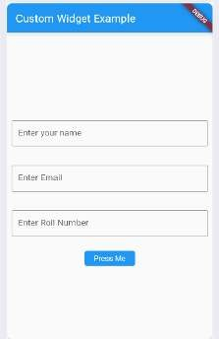

  - Apply styling using themes and custom styles
In Flutter, you can apply styling to your widgets using themes and custom styles to maintain consistency and make your UI morevisually appealing.
import'package:flutter/material.dart';
void main()
{
runApp(MyApp());
}

class MyApp extendsStatelessWidget { @override
Widget build(BuildContext context)
{
return MaterialApp( theme:
ThemeData(
// Define the overall theme of the app
primaryColor: Colors.blue, accentColor:
Colors.orange, fontFamily: 'Roboto', textTheme: TextTheme(
headline1: TextStyle(fontSize: 24, fontWeight: FontWeight.bold), bodyText1: TextStyle(fontSize: 16),
),
elevatedButtonTheme: ElevatedButtonThemeData( style: ElevatedButton.styleFrom(
primary: Colors.blue,
textStyle: TextStyle(fontSize: 18),

padding: EdgeInsets.symmetric(horizontal: 20, vertical: 15), shape: RoundedRectangleBorder(
borderRadius: BorderRadius.circular(10),
),
),
),
),
home: HomePage(),
);
}
}

class HomePage extends StatelessWidget { @override
Widget build(BuildContext context) {
return Scaffold( appBar:
AppBar( title: Text('Styling Example'),
),
body: Center( child: Column(
mainAxisAlignment: MainAxisAlignment.center, children:
<Widget>[ T ext(
'Welcome to MyApp',
style: Theme.of(context).textTheme.headline1,
),
SizedBox(height: 20), ElevatedButton( onPressed: () {},
child: Text('Get Started'),
),
],
),
),
);
} }

Output:
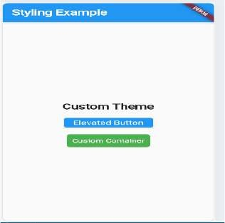

.
Lab Session 7:

  - Design a form with various input fields
import'package:flutter/material.dart'; void main() {runApp(MyApp());
}

classMyAppextendsStatelessWidget{@override
Widgetbuild(BuildContextcontext){returnMateri alApp(
title:'FormExample',
theme:ThemeData(primarySwatch:Colors.blue,
),
home:FormPage(),
);
}
}

classFormPageextendsStatefulWidget{@override
_FormPageStatecreateState()=>_FormPageState();
}

class_FormPageStateextendsState<FormPage>{final_formKey = GlobalKey<FormState>();
String_name;String_email; bool_subscribeToNewsletter=false;String
_selectedCountry = 'USA';
@override Widgetbuild(BuildContextcontext)
{returnScaffo ld(
appBar:AppBar( title:Text('Fo rmExample'),
),

body:Padding( padding:EdgeInsets.all(20.0),child:Fo rm( key:_formKey,child:Column(
crossAxisAlignment:CrossAxisAlignment.start,children:<Widget>[ TextFor mField(
decoration: InputDecoration(labelText: 'Name'),onSaved: (value) {

_name=value;
},
),
SizedBox(height:20),TextFormField(
decoration: InputDecoration(labelText: 'Email'),onSaved: (value) {
_email=value;
},
),
SizedBox(height:20),Row( children:<Widget
>[ Checkbox( value:_subscribeToNewslette r,onChanged:
(value) {setState((){
_subscribeToNewsletter=value;
});
},
),
Text('SubscribetoNewsletter'),
],
),
SizedBox(height:20),Row( children:<Widget
>[ Text('Country:'),SizedBox(width:20),Dropd
ownButton<String>(value:_selectedCountr y,onChanged: (value) {
setState((){
_selectedCountry=value;
});},

items:<String>['USA','Canada','UK','Australia']
.map<DropdownMenuItem<String>>((String value)
{returnDropdownMenuItem<String>( value:va lue,child:Text(value),
);
}).toList(),
),
],

),
SizedBox(height:20),ElevatedButton(onP ressed: () {
_formKey.currentState.save();
//Submittheformdataprint('Name:$_name');print('Email:$_email'); print('SubscribetoNewsletter:$_subscribeToNewsletter'); print('Country:
$_selectedCountry');
},
child:Text('Submit'),

),
],
),
),
),
);
}}

Output:

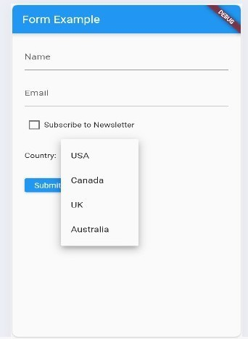

  - Implement form validation and error handling
import'package:flutter/material.dart'; void main() {
runApp(MyApp());
}
classMyAppextendsStatelessWidget{@override Widgetbuild(BuildContextcontext){returnMateri alApp(
home:Scaffold(appBar:AppBar( title:T ext('FormExample'),
),

body:SingleChildScrollView(padding:EdgeIns ets.all(16),child:FormWidget(),
),
),
);
}
}

classFormWidgetextendsStatefulWidget{@override
_FormWidgetStatecreateState()=>_FormWidgetState();
}

class_FormWidgetStateextendsState<FormWidget>{ final
_formKey=GlobalKey<FormState>();String_na me; String_email;String_password;String_ phone;String_address;
@override Widgetbuild(BuildContextcontext)
{returnForm(
key:_formKey,child:Column( crossAxisAlignment:Cross AxisAlignment.start,children:
<Widget>[ TextFormFi eld(
decoration: InputDecoration(labelText: 'Name'),validator: (value) {
if(value.isEmpty)
{ return'Pleaseenteryourname';
}
returnnull;
},
onSaved:(value)=>_name=value,
),
SizedBox(height:16),TextFormField( decoration:Inp utDecoration(labelText:'Email'),
keyboardType:TextInputType.emailAddress,validator: (value) {
if(value.isEmpty){ return'Pleaseenteryouremail';
}
},
onSaved:(value)=>_email=value,
),
SizedBox(height:16),TextFormField( decoration:Inp utDecoration(labelText:'Password'),
obscureText:true,validator:(value)
{ if(value.isEmpty){

return'Pleaseenterapassword';
}
//Addmorecomplexpasswordvalidationlogicifneededreturnnu ll;
},
onSaved:(value)=>_password=value,
),
SizedBox(height:16),TextFormField( decoration:Inp utDecoration(labelText:'Phone'),
keyboardType:TextInputType.phone,validator: (value) {
if(value.isEmpty){ return'Pleaseenteryourphonenumber';
}
},
onSaved:(value)=>_phone=value,
),
SizedBox(height:16),TextFormField(
decoration: InputDecoration(labelText:
'Address'),maxLines:3, validator:(value){
if(value.isEmpty)
{ return'Pleaseenteryouraddress';
}
returnnull;
},
onSaved:(value)=>_address=value,
),
SizedBox(height:16),ElevatedButton(onPr essed:_submitForm,child:Text('Submit'),
),
],
),
);
}
void_submitForm(){ if(_formKey.currentState.validate()){
_formKey.currentState.save();
//Performformsubmissionwiththesavedformdataprint('Forms ubmitted:');
print('Name:$_name'); print('Email:
$_email');print('Password:$_passw ord');print('Phone:
$_phone');print('Address:$_ address');
}
}
}

Output:
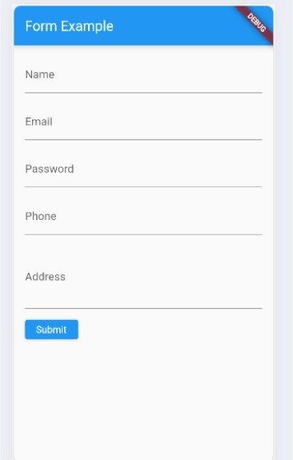

Lab Session 8:

  - Add animations to UI elements using flutter's animation framework
import'package:flutter/material.dart'; void main() {
runApp(MyApp());
}

classMyAppextendsStatelessWidget{@override Widgetbuild(BuildContextcontext){returnMateri alApp(
home:Scaffold(appBar:AppBar( title:T ext('AnimationExample'),
),
body:AnimationWidget(),
),
);
}
}

classAnimationWidgetextendsStatefulWidget{@override
_AnimationWidgetStatecreateState()=>_AnimationWidgetState();
}

class _AnimationWidgetState extends State<AnimationWidget>with SingleTickerProviderStateMixin
{
AnimationController_controller;Animation<doub le>_animation;
@override
void initState() {super.initState();
_controller=AnimationController(duration: Duration(seconds: 1),vsync:this,
);
_animation=Tween<double>(begin:0,end:300).animate(_controller)
..addListener((){ setState((){});//Triggerrebuildwhenanimationvaluechanges
});
}
@override Widgetbuild(BuildContextcontext)
{returnCenter (
child:Column(
mainAxisAlignment:MainAxisAlignment.center, children:<Widget>[

Container( width:_animation.value,height:_ animatio n.value,color:Colors.blue, child:FlutterLogo(size:100),
),
SizedBox(height:20),ElevatedButton(onP ressed: () {
if(_controller.status==AnimationStatus.completed){
_controller.reverse();
}else{
_controller.forward();
}
},
child:Text(
_controller.status==AnimationStatus.completed
?'ReverseAnimation'
:'Start Animation',
),
),
],
),
);
}
@override voiddispose()
{
_controller.dispose();super.dispose();
}
}

Output:
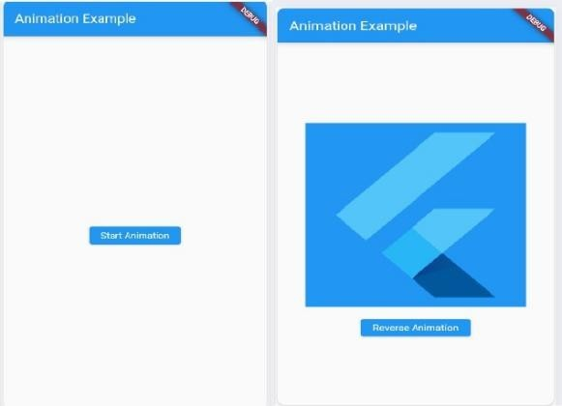

  - Experiment with different types of animations like fade,slide,etc.
Fade Animation:
import'package:flutter/material.dart'; void main() {runApp(MyApp());
}

classMyAppextendsStatelessWidget{@override Widgetbuild(BuildContextcontext){returnMateri alApp(
home:Scaffold(appBar:AppBar( title:T ext('FadeAnimationExample'),
),
body:FadeAnimation(),
),
);
}
}

classFadeAnimationextendsStatefulWidget{@overrid e
_FadeAnimationStatecreateState()=>_FadeAnimationState();
}

class_FadeAnimationStateextendsState<FadeAnimation>wit h SingleTickerProviderStateMixin
{AnimationController_controller; Animation<double>_animation;
@override
void initState() {super.initState();
_controller=AnimationController(vsync:this, duration:Duration(seconds:2),
);
_animation=Tween<double>(begin:0.0, end: 1.0,
).animate(_controller);

_controller.forward();
}

@override Widgetbuild(BuildContextcontext)
{returnCenter ( child:FadeTransition(opacity:_animation

,child:Container(width:200, height:200, color:Colors.blue,
),
),
);
}
@override voiddispose()
{
_controller.dispose();super.dispose();
}
}

Slide Animation:
import'package:flutter/material.dart'; void main() {runApp(MyApp());
}

classMyAppextendsStatelessWidget{@override Widgetbuild(BuildContextcontext){
returnMaterialApp(home:Scaffold(app Bar:AppBar( title:Text('SlideAnimatio
nExample'),
),
body:SlideAnimation(),
),
);
}
}
classSlideAnimationextendsStatefulWidget{@override
_SlideAnimationStatecreateState()=>_SlideAnimationState();
}
class_SlideAnimationStateextendsState<SlideAnimation>wit h SingleTickerProviderStateMixin
{AnimationController_controller; Animation<Offset>_animation;@override void initState() {super.initState();
_controller=AnimationController(
vsync:this, duration:Duration(seconds:2),
);
_animation=Tween<Offset>(begin: Offset(- 1.0, 0.0),
end:Offset(0.0,0.0),
).animate(_controller);

_controller.forward();
}

@override Widgetbuild(BuildContextcontext)
{returnCenter ( child:SlideTransition(position:_animatio n,child:Container(width:200,
height:200, color:Colors.blue,
),
),
);
}

@override voiddispose()
{
_controller.dispose();super.dispose();
}
}
ScaleAnimation: import'package:flutter/material.dart';

void main() {runApp(MyApp());
}

classMyAppextendsStatelessWidget{@override Widgetbuild(BuildContextcontext){returnMateri alApp(
home:Scaffold(appBar:AppBar( title:T ext('ScaleAnimationExample'),
),
body:ScaleAnimation(),
),
);
}
}

classScaleAnimationextendsStatefulWidget{@override
_ScaleAnimationStatecreateState()=>_ScaleAnimationState();
}

class_ScaleAnimationStateextendsState<ScaleAnimation>wit h SingleTickerProviderStateMixin
{AnimationController_controller; Animation<double>_animation;

@override
void initState() {super.initState();
_controller=AnimationController(vsync:this, duration:Duration(seconds:2),
);
_animation=Tween<double>(begin:0.0, end: 1.0,
).animate(_controller);
_controller.forward();
}
@override Widgetbuild(BuildContextcontext)
{returnCenter ( child:ScaleTransition(scale:_animation,c hild:Container(width:200,
height:200, color:Colors.blue,
),
),
);
}

@override voiddispose()
{
_controller.dispose();super.dispose();
}
}

Output:
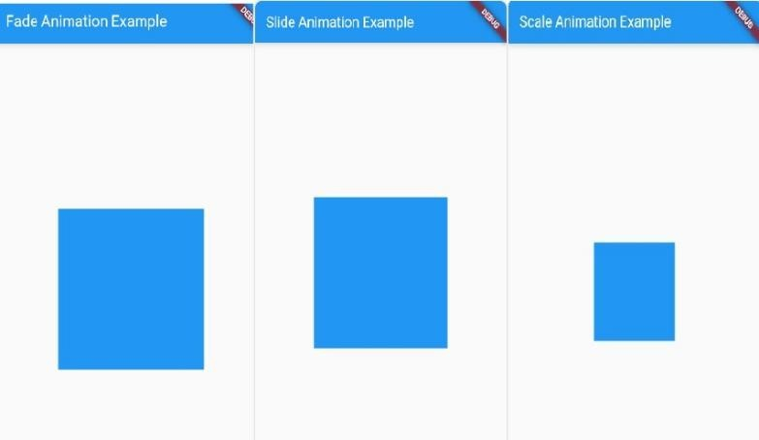

Lab Session 9:

  - Fetch data from RESTAPI
add dependency in pubspec.yaml:
dependencies:
flutter:
sdk:flutter http:^0.13.3
enable internet permissions in your AndroidManifest.xml file for Android apps like below.
<uses-permission android:name="android.permission.INTERNET"
import'dart:convert'; import'package:flutter/material.dart'; import'package:http/http.dart'ashttp;

void main() {runApp(MyApp());
}

classMyAppextendsStatelessWidget{@override
Widgetbuild(BuildContextcontext){returnMateri alApp(
home:HomePage(),
);
}
}

classHomePageextendsStatefulWidget{@override
_HomePageStatecreateState()=>_HomePageState();
}

class_HomePageStateextendsState<HomePage>{List<dynami c> _data = [];
@override
void initState() {super.initState();
_fetchDataFromApi();
}

Future<void>_fetchDataFromApi()async{ finalresponse=awaithttp.get(Uri.parse('https:/
/jsonplaceholder.typicode.com/posts'));

if(response.statusCode==200){setState((){
_data=json.decode(response.body);
});

}else{ throwException('Failedtoloaddat a');
}
}
@override Widgetbuild(BuildContextcontext)
{returnScaffo ld(
appBar:AppBar( title:Text('APIDataEx ample'),
),
body:ListView.builder(itemCount:_data.length
,itemBuilder:(context,index){returnListTile( title:Text(_data[index] ['title']),subtitle:Text(_dat
a[index]['body']),
);
},
),
);
}

Output:

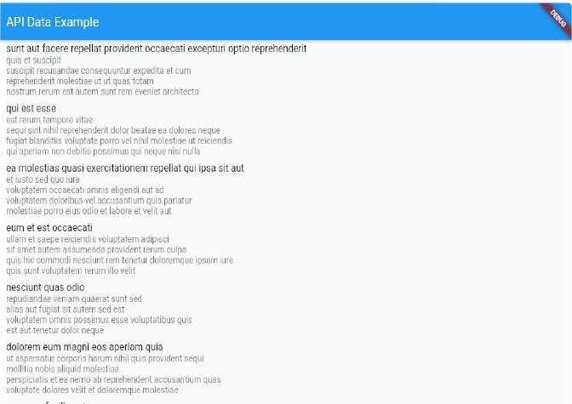

  - Display the fetched data in a meaningful way in the UI
import'dart:convert'; import'package:flutter/material.dart'; import'package:http/http.dart'ashttp;
void main() {runApp(MyApp());
}
classMyAppextendsStatelessWidget{@override Widgetbuild(BuildContextcontext){returnMateri alApp(
home:HomePage(),
);
}
}

classHomePageextendsStatefulWidget{@override
_HomePageStatecreateState()=>_HomePageState();
}

class_HomePageStateextendsState<HomePage>{List<dynami c> _data = [];
bool_isLoading=false;

@override
void initState() {super.initState();
_fetchDataFromApi();
}

Future<void>_fetchDataFromApi()async{setState(()
{
_isLoading=true;
});
finalresponse=awaithttp.get(Uri.parse('https://jsonplaceholder.typicode.com/posts')); if(response.statusCode==200){setState((){
_data=json.decode(response.body);
_isLoading=false;
});
}else{ throwException('Failedtoloaddata');
}

}

@override
Widgetbuild(BuildContextcontext){returnScaffo ld(
appBar:AppBar( title:Text('APIDataEx ample'),
),
body:_isLoading
? Center( child:CircularProgressIndicator(),
)
:ListView.builder(itemCount:_data.length,
itemBuilder:(context,index)
{returnPostCard( title:_data[index]['title'],
body:_data[index]['body'],
);
},
); ),
}
}

classPostCardextendsStatelessWidget{final String title;
finalStringbody;

constPostCard({Keykey,@requiredthis
.title, @requiredthis.body,
}):super(key:key);
@override Widgetbuild(BuildContextcontext)
{returnCard( margin:EdgeInsets.symmetric(horizontal:16,vertical:8),child
:Padding(
padding:EdgeInsets.all(16),child:Column( crossAxis Alignment:CrossAxisAlignment.start,
children:<Widget>[Text( title,
style:TextStyle(fontSize:18,fontWeight:FontWeight.bold),
),
SizedBox(height:8),Text( body, style:TextStyle(fontSize:16),
),
],
),
),
);
}

}

Output:
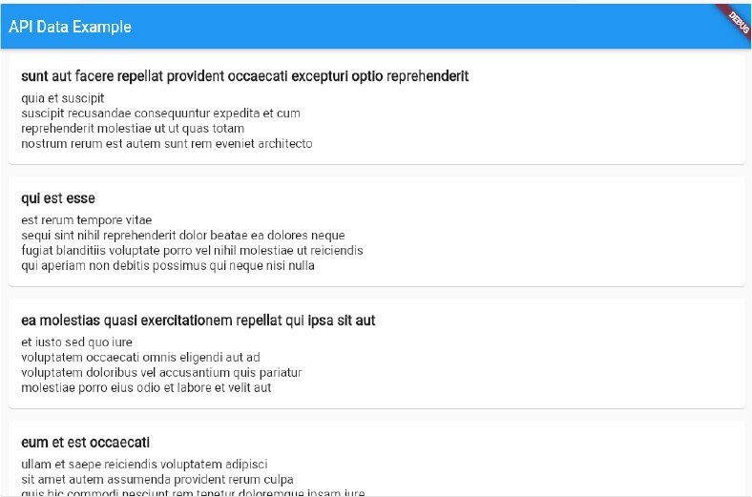

Lab Session 10:

  - Write unit tests for UI components
import'package:flutter/material.dart';
import'package:flutter_test/flutter_test.dart'; import'package:your_app/post_card.dart';
voidmain(){
testWidgets('PostCard displays title and body',(WidgetTester tester)async{ await tester.pumpWidget(
MaterialApp( home:
PostCard( title:
'Test Title', body:'TestBody',
),
),
);

expect(find.text('Test Title'), findsOneWidget);
expect(find.text('Test Body'), findsOneWidget);
});
testWidgets('PostCardwidgethascorrectstyling',(WidgetTestertester)async{
//Buildourwidgetandtriggeraframe.awaittester.pu mpWidget(MaterialApp(
home:PostCard(title: 'Test Title',body:'TestBody',
),
),
);

//Verifythatthetextstylesareappliedcorrectly. finaltitleText=tester.widget<Text>(find.text('TestTitle'));exp ect(titleText.style.fontSize,18);expect(titleText.style.fontWei ght,FontWeight.bold);
finalbodyText=tester.widget<Text>(find.text('TestBody'));exp ect(bodyText.style.fontSize,16);
});
}

In this test:
We use the testWidgets function from the flutter_test package to define our test cases.
In the first test case, we ensure that the PostCard widget correctly displays the provided title and body text.

In the second test case, we verify that the text styles applied to the title and body texts are as expected. We use expect statements to assert that the expected UI elements are found on the screen and that their properties match the expected values.
Make sure to replace your_app with the appropriate package name where your PostCard widget resides.
Run the tests using the following command:
flutter test
This will execute all the tests defined in your project, including the ones written for the UI components.
Make sure to provide different test scenarios and edge cases to ensure comprehensive test coverage for your UI components.

  - Use flutter's debugging tools to identify and fix issues?
demonstrate the use of Flutter's debugging tools, let's consider a scenario where we have a simple counter app, but there's a bug where the counter is not incrementing when the "+" button is pressed. We'll use Flutter's debugging tools to identify and fix this issue. Here's the code for the counter app:
import 'package:flutter/material.dart'; void main() {runApp(MyApp());
}
classMyAppextendsStatelessWidget{@override Widgetbuild(BuildContextcontext){returnMateri alApp(
home:CounterApp(),
);
}
}
classCounterAppextendsStatefulWidget{@override
_CounterAppStatecreateState()=>_CounterAppState();
}
class_CounterAppStateextendsState<CounterApp>{int
_counter = 0;
void_incrementCounter(){
_counter++;
}
@override Widgetbuild(BuildContextcontext)
{returnScaffo ld( appBar:AppBar( title:Text('Co unterApp'),
),
body:Center(child:Column(mainAxisAlignment:MainAxisAlignment.center,

children:<Widget>[Text(
'Counter:', style:TextStyle(fontSize:24),
),
Text('$_counter', style:TextStyle(fontSize:36,fontWeight:FontWeight.bold),
),
],
),
),
floatingActionButton:FloatingActionButton(onPressed:_i ncrementCounter, tooltip:'Increment',child:Icon(Icons.add),
),
);
}
}

Now, let's use Flutter's debugging tools to identify and fix the issue:
Widget Inspector: First, let's inspect the widget tree to see if the "+" button is correctly wired to the
_incrementCounter method. We can do this by running the app in debug mode and enabling the widget inspector. You can do this by clicking the "Open DevTools" button in your IDE (Android Studio/IntelliJ IDEA or Visual Studio Code) or running the following command in your terminal: flutter run –debug

Once the app is running, click on the "Toggle Widget Inspector" button in the top-right corner of your app. Then, select the FloatingActionButton widget representing the "+" button. Ensure that the onPressed callback is correctly set to _incrementCounter.

Debugging Console: If everything looks fine in the widget inspector, we can add some debug print statements to the _incrementCounter method to see if it's being called when the button is pressed. Modify the _incrementCounter method as follows:
void_incrementCounter(){ print('Incrementingcounter');
_counter++;
}
Now, run the app again in debug mode and observe the console output when you press the "+" button. If you don't see the "Incrementing counter" message in the console, it means the
_incrementCounter method is not being called.

Breakpoints: As a final step, let's set a breakpoint in the _incrementCounter method and debug the app to see if it's being hit. Add a breakpoint by clicking on the left margin of the
_incrementCounter method in your code editor. Then, run the app in debug mode and press the "+" button. The app should pause at the breakpoint, allowing you to inspect the current state and variables. You can step through the code to see if there are any issues with the execution flow.

By using Flutter's debugging tools, you should be able to identify the issue with the counter app and fix it accordingly. In this case, if the debugging process reveals that the
_incrementCounter method is not being called, you can double-check the on Pressed callback of the FloatingActionButton to ensure it's correctly wired to the _incrementCounter method

